Chapter 13, Problem 83.

Find I_{x} and V_{x} in the circuit of Fig. 13.142 below using PSpice.
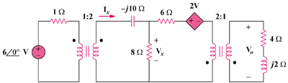
2V_{x}

Figure 13.142
For Prob. 13.83.

